Endometrial Cancer



**Endometrial cancer is a type of cancer that begins in the uterus. The uterus is the hollow, pear-shaped pelvic organ where fetal development occurs.**

**Endometrial cancer begins in the layer of cells that form the lining (endometrium) of the uterus. Endometrial cancer is sometimes called uterine cancer. Other types of cancer can form in the uterus, including uterine sarcoma, but they are much less common than endometrial cancer.**

**Endometrial cancer is often detected at an early stage because it frequently produces abnormal vaginal bleeding. If endometrial cancer is discovered early, removing the uterus surgically often cures endometrial cancer.**

**Symptoms**

**Signs and symptoms of endometrial cancer may include:**

* **Vaginal bleeding after menopause**
* **Bleeding between periods**
* **Pelvic pain**

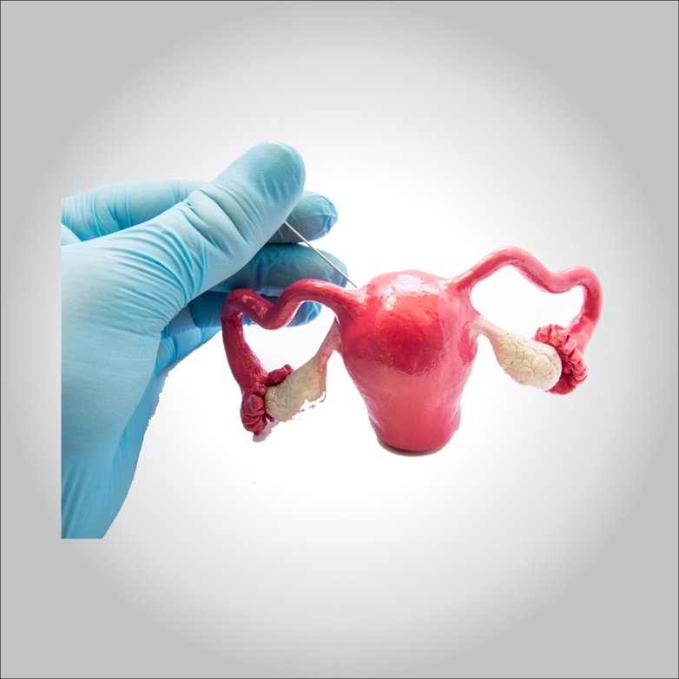

**When to see a doctor**

**Make an appointment with your doctor if you experience any persistent signs or symptoms that worry you.**

**Causes behind Endometrial cancer**

**Doctors don’t know what causes endometrial cancer. What’s known is that something occurs to create changes (mutations) in the DNA of cells in the endometrium — the lining of the uterus.**

**The mutation turns normal, healthy cells into abnormal cells. Healthy cells grow and multiply at a set rate, eventually dying at a set time. Abnormal cells grow and multiply out of control, and they don’t die at a set time. The accumulating abnormal cells form a mass (tumor). Cancer cells invade nearby tissues and can separate from an initial tumor to spread elsewhere in the body (metastasize).**

**Risk factors**

**Factors that increase the risk of endometrial cancer include:**

* **Changes in the balance of female hormones in the body. The ovaries make two main female hormones — estrogen and progesterone. Fluctuations in the balance of these hormones cause changes in the endometrium.**

**A disease or condition that increases the amount of estrogen, but not the level of progesterone, in your body can increase your risk of endometrial cancer. Examples include irregular ovulation patterns, which might happen in polycystic ovary syndrome, obesity and diabetes. Taking hormones after menopause that contain estrogen but not progesterone increases the risk of endometrial cancer.**

**A rare type of ovarian tumor that secretes estrogen also can increase the risk of endometrial cancer.**

* **More years of menstruation. Starting menstruation at an early age — before age 12 — or beginning menopause later increases the risk of endometrial cancer. The more periods you’ve had, the more exposure your endometrium has had to estrogen.**
* **Never having been pregnant. If you’ve never been pregnant, you have a higher risk of endometrial cancer than someone who has had at least one pregnancy.**
* **Older age. As you get older, your risk of endometrial cancer increases. Endometrial cancer occurs most often after menopause.**
* **Obesity. Being obese increases your risk of endometrial cancer. This may occur because excess body fat alters your body’s balance of hormones.**
* **Hormone therapy for breast cancer. Taking the hormone therapy drug tamoxifen for breast cancer can increase the risk of developing endometrial cancer. If you’re taking tamoxifen, discuss this risk with your doctor. For most, the benefits of tamoxifen outweigh the small risk of endometrial cancer.**
* **An inherited colon cancer syndrome. Lynch syndrome, also called hereditary nonpolyposis colorectal cancer (HNPCC), is a syndrome that increases the risk of colon cancer and other cancers, including endometrial cancer. Lynch syndrome is caused by a gene mutation passed from parents to children. If a family member has been diagnosed with Lynch syndrome, discuss your risk of the genetic syndrome with your doctor. If you’ve been diagnosed with Lynch syndrome, ask your doctor what cancer screening tests you should undergo.**

**Prevention**

**To reduce your risk of endometrial cancer, you may wish to:**

* **Talk to your doctor about the risks of hormone therapy after menopause. If you’re considering hormone replacement therapy to help control menopause symptoms, talk to your doctor about the risks and benefits. Unless you’ve undergone a hysterectomy, replacing estrogen alone after menopause may increase your risk of endometrial cancer. Taking a combination of estrogen and progestin can reduce this risk. Hormone therapy carries other risks, so weigh the benefits and risks with your doctor.**
* **Consider taking birth control pills. Using oral contraceptives for at least one year may reduce endometrial cancer risk. The risk reduction is thought to last for several years after you stop taking oral contraceptives. Oral contraceptives have side effects, though, so discuss the benefits and risks with your doctor.**
* **Maintain a healthy weight. Obesity increases the risk of endometrial cancer, so work to achieve and maintain a healthy weight. If you need to lose weight, increase your physical activity and reduce the number of calories you eat each day.**

**Diagnosing endometrial cancer**

**Tests and procedures used to diagnose endometrial cancer include:**

* **Examining the pelvis. During a pelvic exam, your doctor carefully inspects the outer portion of your genitals (vulva), and then inserts two fingers of one hand into your vagina and simultaneously presses the other hand on your abdomen to feel your uterus and ovaries. He or she also inserts a device called a speculum into your vagina. The speculum opens your vagina so that your doctor can view your vagina and cervix for abnormalities.**
* **Using sound waves to create a picture of your uterus. Your doctor may recommend a transvaginal ultrasound to look at the thickness and texture of the endometrium and help rule out other conditions. In this procedure, a wandlike device (transducer) is inserted into your vagina. The transducer uses sound waves to create a video image of your uterus. This test helps your doctor look for abnormalities in your uterine lining.**
* **Using a scope to examine your endometrium. During a hysteroscopy, your doctor inserts a thin, flexible, lighted tube (hysteroscope) through your vagina and cervix into your uterus. A lens on the hysteroscope allows your doctor to examine the inside of your uterus and the endometrium.**
* **Removing a sample of tissue for testing. To get a sample of cells from inside your uterus, you’ll likely undergo an endometrial biopsy. This involves removing tissue from your uterine lining for laboratory analysis. Endometrial biopsy may be done in your doctor’s office and usually doesn’t require anesthesia.**
* **Performing surgery to remove tissue for testing. If enough tissue can’t be obtained during a biopsy or if the biopsy results are unclear, you’ll likely need to undergo a procedure called dilation and curettage (D&C). During D&C, tissue is scraped from the lining of your uterus and examined under a microscope for cancer cells.**

**If endometrial cancer is found, you’ll likely be referred to a doctor who specializes in treating cancers involving the female reproductive system (gynecologic oncologist).**

**Staging endometrial cancer**

**Once your cancer has been diagnosed, your doctor works to determine the extent (stage) of your cancer. Tests used to determine your cancer’s stage may include a chest X-ray, a computerized tomography (CT) scan, positron emission tomography (PET) scan and blood tests. The final determination of your cancer’s stage may not be made until after you undergo surgery to treat your cancer.**

**Your doctor uses information from these tests and procedures to assign your cancer a stage. The stages of endometrial cancer are indicated using Roman numerals ranging from I to IV, with the lowest stage indicating that the cancer hasn’t grown beyond the uterus. By stage IV, the cancer has grown to involve nearby organs, such as the bladder, or has spread to distant areas of the body.**

**How to treat endometrial cancer?**

**Treatment for endometrial cancer is usually with surgery to remove the uterus, fallopian tubes and ovaries. Another option is radiation therapy with powerful energy. Drug treatments for endometrial cancer include chemotherapy with powerful drugs and hormone therapy to block hormones that cancer cells rely on. Other options might be targeted therapy with drugs that attack specific weaknesses in the cancer cells and immunotherapy to help your immune system fight cancer.**

**Surgery**

**Treatment for endometrial cancer usually involves an operation to remove the uterus (hysterectomy), as well as to remove the fallopian tubes and ovaries (salpingo-oophorectomy). A hysterectomy makes it impossible for you to become pregnant in the future. Also, once your ovaries are removed, you’ll experience menopause, if you haven’t already.**

**During surgery, your surgeon will also inspect the areas around your uterus to look for signs that cancer has spread. Your surgeon may also remove lymph nodes for testing. This helps determine your cancer’s stage.**

**Radiation therapy**

**Radiation therapy uses powerful energy beams, such as X-rays and protons, to kill cancer cells. In some instances, your doctor may recommend radiation to reduce your risk of a cancer recurrence after surgery. In certain situations, radiation therapy may also be recommended before surgery, to shrink a tumor and make it easier to remove.**

**If you aren’t healthy enough to undergo surgery, you may opt for radiation therapy only.**

**Radiation therapy can involve:**

* **Radiation from a machine outside your body. During external beam radiation, you lie on a table while a machine directs radiation to specific points on your body.**
* **Radiation placed inside your body. Internal radiation (brachytherapy) involves placing a radiation-filled device, such as small seeds, wires or a cylinder, inside your vagina for a short period of time.**

**Chemotherapy**

**Chemotherapy uses chemicals to kill cancer cells. You may receive one chemotherapy drug, or two or more drugs can be used in combination. You may receive chemotherapy drugs by pill (orally) or through your veins (intravenously). These drugs enter your bloodstream and then travel through your body, killing cancer cells.**

**Chemotherapy is sometimes recommended after surgery if there’s an increased risk that the cancer might return. It can also be used before surgery to shrink the cancer so that it’s more likely to be removed completely during surgery.**

**Chemotherapy may be recommended for treating advanced or recurrent endometrial cancer that has spread beyond the uterus.**

**Hormone therapy**

**Hormone therapy involves taking medications to lower the hormone levels in the body. In response, cancer cells that rely on hormones to help them grow might die. Hormone therapy may be an option if you have advanced endometrial cancer that has spread beyond the uterus.**

**Targeted drug therapy:**

**Targeted drug treatments focus on specific weaknesses present within cancer cells. By blocking these weaknesses, targeted drug treatments can cause cancer cells to die. Targeted drug therapy is usually combined with chemotherapy for treating advanced endometrial cancer.**

**Immunotherapy**

**Immunotherapy is a drug treatment that helps your immune system to fight cancer. Your body’s disease-fighting immune system might not attack cancer because the cancer cells produce proteins that blind the immune system cells. Immunotherapy works by interfering with that process. For endometrial cancer, immunotherapy might be considered if the cancer is advanced and other treatments haven’t helped.**